**DAILY PROTOCOL – MULTIPLE CAGES (PUMP SYSTEM)**

**8:00 – 14:00**

**Procedure 1 – Daily Morning Check**

1. Move the PC cursor to activate the screen and check if any of the green lights from the flowers are on. Normally no green lights (LS1-LS10) should be visible unless a nose-poke occurs. If you see a light that is on, check to see if the infrared sensor is blocked by nectar or other residue. Write this down in the form if it is so.
2. Go to the computer and check to see how many visits the animals made. Check the Tab “Analysis” to see which side the animals preferred, and then run the Shiny app (in the Control folder) with the data from the previous night.
3. Check to see if any of the animals have drunk less than the recommended amount. Write this down in the form.
4. Have a look at the total volume consumed by all the bats through the night as calculated by the Shiny app and then go into the Experiment Room to see how much was actually consumed from the previous night. Write both of these down in the form and see if they are approximately the same.
5. Remove the nectar reservoir from the Experiment Room.
6. If any bat has not drunk enough, take the bat out of the cage carefully, and feed it with honey water a few times.
7. Take a copy of the previous night’s data, and put it on the USB stick so it can be taken to the computer in Haus 4.
8. Now take the temperature/humidity sensor into the Experiment Room, wait for a minute, and then write down the temperature and humidity in the form.
9. Check and see if there are big air bubbles in the system. Write this down if so.
10. Check to see if the small Teflon tubes are connected to the flower heads.
11. See if the doors are all in the correct positions: Adlib = open; Other stages = closed.
12. Remove the tubes from the flower heads and put them in the plastic cups to drain.
13. Quit the program. If it is an alcohol-cleaning day (Mondays & Thursdays) proceed with Procedure 2. If not, continue with Procedure 3.

**Procedure 2 – Alcohol Cleaning**

1. Open the program “Flush_dynspeed” in PhenoSoft Control.
2. Place the nectar tube in de-calcified water and leave the water and alcohol tubes in the air. Run the ‘Rinse’ procedure.
3. When the procedure is finished, place the nectar tube in the alcohol and run the ‘Alcohol’ procedure.
4. When the procedure is finished, remove the alcohol, place the nectar tube in water again. Open the nectar valve and suck in some water. Close the nectar valve, open the waste valve and push the water into the waste. Close the waste valve. Repeat this until the water flowing into the syringe is completely clear and not milky white.
5. Fix the syringe back to the pump, close all the valves and now run the ‘Final Flush’ procedure. When it is finished, continue with Procedure 3, step 4.

**Procedure 3 – Afternoon Cage Procedure**

1. Open the program “Flush_allcages” in PhenoSoft Control.
2. Place the nectar tube in the water. Press the “Rinse” button and wait for the system to finish clearing the old nectar from the system. During this time you can carry out the steps in “Procedure 4 - Soup Kitchen”. In particular, prepare sugar water for the day if necessary.
3. When the system has finished clearing all the old nectar from the system, unscrew the syringe from the pump and wash it thoroughly with hot water. Wipe it dry.
4. Clean the nectar reservoir and fill it with fresh nectar, about 200 mL.
5. Replace the nectar reservoir but do not put the nectar tube into it yet.
6. Fix the syringe to the pump. Open the Nectar valve, suck in the remaining water. Open Waste, close Nectar and empty this. Open Nectar and close Waste again and now fill up the syringe with nectar so that there is no air in the syringe or the tube.
7. Replace the syringe in the black holder, push or pull the plunger until it fits to the plunger holder and screw the syringe in place.
8. When the syringe is in its place, close the reservoir valve and press the ‘Fill’ button.
9. When it’s finished, quit the program, and now reopen the proper configuration file for the day.
10. Using the test transponders, make visits to all the flowers: the system should reward you when you do that. Check the following: the rewards are being delivered as per the pre-programmed lists; the doors are moving without a problem; the doors are not making a squeaking noise and reaching their proper position.
11. On the first 2 visits let the nectar drip down into the cups. Then re-connect the nectar tubes to the flower heads and make 2 more visits. Make sure the tube is sticking out just a little so the nectar is accessible. Use tissue to remove excess solution. If you see air bubbles inside the tubes, keep making visits until they are expelled.
12. Trigger a refill of the system by pressing the “Empty” end switch of the pump and wait until the system is done refilling. Check to see that no air is leaking in the syringe during the refill.
13. When the system is refilled, remove the drainage cups, empty and rinse them out. Hang them back on the cages.
14. In the log, write down the time you last started the program at (you can see it from the screen if you don’t remember).
15. Leave a feeder of honey water in the cages of those bats that were underperforming. Make sure to remove it after an hour.

**Procedure 4 – Soup Kitchen**

1. Prepare sugar solution for 2 days at a time, about 400 mL of the required concentration.
2. Remove the Eppendorfs from the cages and weigh them. Write this down.
3. Clean the Eppendorfs. Prepare a mixture of 1.2 g Nektar-Plus, 1.8 g Milasan and 13 g water. Fill this up in the Eppendorfs and weigh them. Write down the weights.

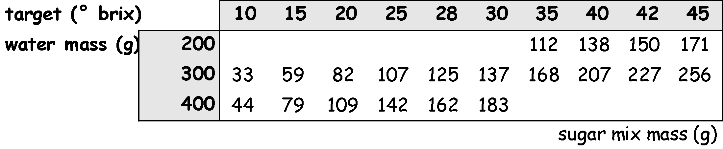

**Procedure 5 – Final Afternoon Check**

1. Place the Eppendorfs of food and water into the cages.
2. Make a note of the volume of nectar in the reservoirs.
3. This is the final check before 2 PM:

* Are the tubes in the valves and into the heads of the flowers properly?
* Have the Eppendorfs been opened?
* Are the tubes properly within the flower and pump valves?
* Has the log sheet been filled up?

1. If there are naive bats in any of the cages make sure there is a towel over the flowers in that cage and a cup of honey water on top of each of those flowers.

**Procedure 6 – Daily Evening Check**

**17:00 – 18:00**

1. In the PhenoSoft program, open the Analysis tab. This will show the number of visits each bat has made to each of the two flowers.
2. If the animal has not passed criterion, give them a container of honey water for the night. They can be replaced the next day.